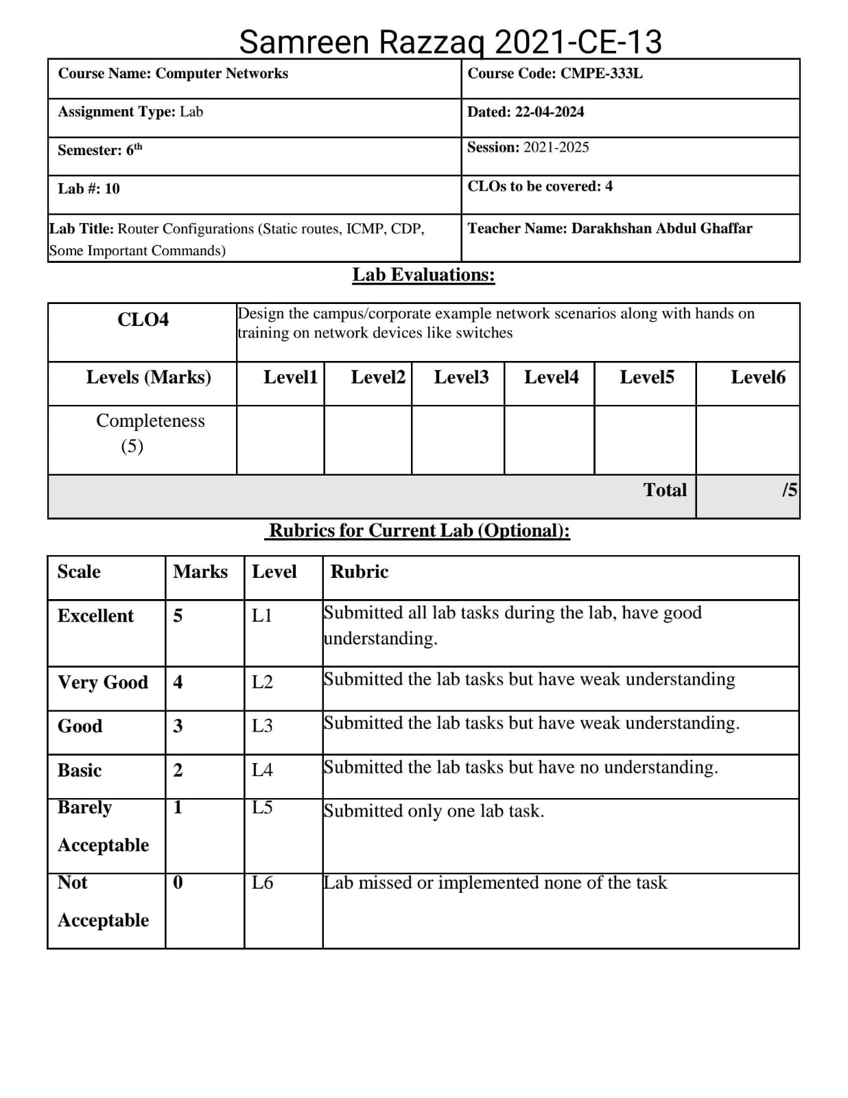

**Exercise 1**

**Lab Task:**

Company XYZ has 100 workstations in their head office and the IT manager would like to assign a subnetwork address for each department. He wants to create 8 subnets using the 192.168.1.0/24 block and assign the first subnetwork to their servers and the rest for their 100 workstations. How will we compute the subnetwork requirement?

**Given:**

Number of workstations = 100

Network address = 192.168.1.0/24

Subnets required = 8

Design the network in Packet tracer and configure all routers using static commands, show packet are moving between all subnets using pings from various attached hosts/workstations.

**Solution:**

